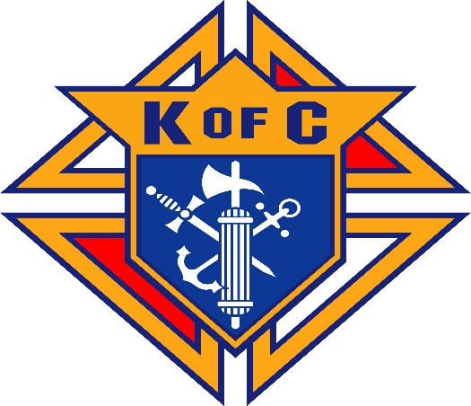
MSGR. Richard C. Madden Council #6629 Summerville, SC

Brothers,
Please remember in your prayers the soul of our brother Knight:

(Copy obituary and place name, birth, and death date)

October 5, 1947 - November 5, 2021

For the Wake, please join us as a group and meet at 6:30PM at the (Insert Funeral Home name and address). We will process in as a group. Dress is: Suit and tie or Suit coat tie and dark pants. Please wear your K of C name tag.

(Copy and Insert Obituary here)

